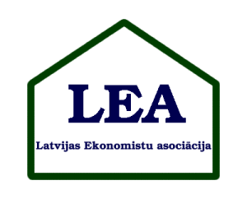

Call for Applications
4th Annual International Conference of
Latvian Economic Association
“Road to prosperity - economic globalization versus economic localization”
Riga, April 24, 2013

Dear Friends and Colleagues!

On behalf of the Latvian Economic Association, I am writing to announce the initial information about the Annual International Conference of the Association. It will take place in Riga, Latvia on April 24th, 2013.

A Young Scholar section will be included. The best young scholars will be awarded.

There is no participation fee for the conference.

Working languages of the conference: English and Latvian.

Deadline for application is March 20, 2013.

More detailed information about the conference will be soon on the association webpage: http://leaekonomisti.lv .

Until this you can use for contacts the following e-mail address: abrivere@td.lv

The date of the conference is reconciled with a conference of BA School of Business and Finance, which will take place in April 25-26. The possibility for publishing papers will be offered to the participants of that conference.

Kind Regards: Ivars Brīvers, Chair of the Association

