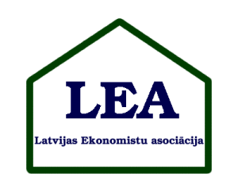

Latvian Economic Association in cooperation with
the Department of Humanities and Social Sciences of
the Latvian Academy of Science
and Business School „Turība”
announces call for papers
for the Karl Ballod 150 Anniversary conference
“The Role of Economic Science in Development of Social Environment and Entrepreneurship”
Riga, April 4, 2014

Dear Friends and Colleagues!

On behalf of the Latvian Economic Association, I am writing to announce the initial information about the Annual International Conference of the Association. It will take place in Riga, Latvia on April 4th, 2014. We look forward to your participation, and ask you to give the information about the conference to your colleagues.

Latvian Economic Association promotes the Young Scholar (undergraduate and graduate students) participation. The best young scholars will be awarded.

There is no participation fee for the conference.

Working languages of the conference: English and Latvian.

Deadline for application is March 10, 2014.

More detailed information about the conference will be soon on the association webpage: http://leaekonomisti.lv .

Until this you can use for contacts the following e-mail address: abrivere@td.lv

Kind Regards: Ivars Brīvers, Chair of the Association

