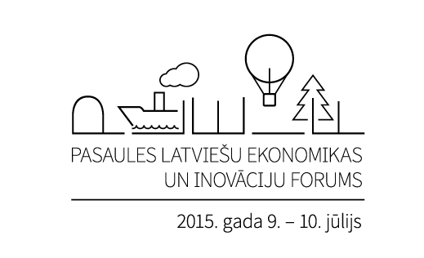

May 11, 2015
On July 10, 2015, the 2nd World Latvian Economics and Innovations Forum will take place in Riga, Latvia
In two months, on July 10, 2015, the 2nd World Latvian Economics and Innovations Forum will be held in Riga, Latvia. Building on discussions, which took place during the first WLEIF in July 2013, the 2nd forum will further expand the dialogue regarding Latvia’s economic development the role of Latvian expatriates in strengthening it.
The 2nd World Latvian Economics and Innovations Forum is organized by the World Federation of Free Latvians (WFFL) in cooperation with the Ministry of Foreign Affairs of the Republic of Latvia. Jānis Kukainis, Chairman of the WFFL, stresses that the aims of the first forum – to promote the engagement of Latvian entrepreneurs and experts living abroad in the strengthening of Latvia’s national economy – are even more significant now in view of current geopolitical tensions and their impact on Latvian economic growth: “This is the time when Latvian professionals abroad can offer assistance to Latvia in the most direct manner, assist Latvian businesses in finding new export markets, develop business ideas and help attract foreign investment.”
Edgars Rinkēvičs, the Minister of Foreign Affairs of Latvia has said that “for Latvia’s national economy, based on the values of liberal economy – openness, competitiveness, and attractive investment environment – it is fundamentally important to follow the latest global trends, innovation and business models. The talented and successful Latvian diaspora living and working outside Latvia is a substantial resource for bringing the latest ideas and successful business models to Latvia. At the same time, every Latvian abroad is an informal envoy for the newest products and innovations, and as a result, increases the visibility of Latvia beyond its borders and contributes to its growth.”
Taking into consideration current geopolitical developments and Latvia's export diversification efforts, one session of the Forum’s program on July 10, 2015 will be dedicated to rethinking strategies for Latvia’s development of new export markets. Participants will include Karlis Smits - World Bank Senior Economist in China, Andris Piebalgs - European and Economic Affairs Adviser to the President of Latvia and former European Commissioner for Energy and for Development, and Artis Pabriks - Member of the European Parliament, Chief reporter on the Canada-European Union: Comprehensive Economic and Trade Agreement.
In another session questions about Latvia's opportunities in attracting foreign investment and promoting innovation will be discussed by Dr Imants Lauks (Canada) - Founder of Epocal Inc., whose work lead to the world’s first commercial scale biochips and who has authored over 50 patents in the field of biosensors, Girts Cimermans (Netherlands) - Executive Officer of a global med-tech company HOYA Corporation, and Janis Krums (USA) - founder and CEO of OPPRTUNITY and private investor in various startups. Separate working groups will be organized on how to promote business with different regions of the world.
In connection with the 2nd World Latvian Economics and Innovations Forum, a separate Pre-Forum Meeting for International Participants will be held on July 9, 2015 and entrepreneurs of Latvian origin and other professionals from abroad are invited to take part. In order to receive additional information and register your participation at the 2nd World Latvian Economics and Innovations Forum, please visit: www.ieguldilatvija.lv.
The 2nd World Latvian Economics and Innovations Forum is organized in cooperation with the Investment and Development Agency of Latvia, Ministry of Economics of the Republic of Latvia, the Latvian Institute, the Stockholm School of Economics in Riga, and the American Chamber of Commerce in Latvia.

